create database company2_db;
use company2_db;
create table employees(emp_id int, emp_name varchar(20),salary int,dept_id int, hiring_date date, location varchar(20));
create table departement(dept_id int, dept_name varchar(20));
insert into employees values(101,"Raj",9000,5,'2024-03-15',"Pune"),
(102,"Shreya",15000,3,'2024-01-05',"Aurangabad"),
(103,"Nisha",40000,1,'2026-02-13',"Nashik"),
(104,"Nil",50000,2,'2015-02-20',"Mumbai"),
(105,"Jay",25000,4,'2016-04-07',"Banglore"),
(106,"Nikhil",15000,3,'2024-02-11',"Hydrabad"),
(107,"Rohan",80000,1,'2022-03-25',"Kolkata"),
(108,"Mohan",9000,5,'2024-02-19',"Solapur"),
(109,"Vivan",65000,5,'2014-09-14',"Ahemdabad"),
(110,"Prem",15000,3,'2024-04-17',"Nagpur"),
(111,"Devid",150000,1,'2015-03-11',"Delhi"),
(112,"Ram",20000,6,"2012-07-22","Goa"),
(113,"Ganesh",30000,4,"2025-03-12","Amravati"),
(114,"Shital",40000,1,"2025-01-15","Aakola"),
(115,"Kedar",10000,5,"2022-02-05","Nagar");
insert into departement values (1,"Manager"),
(2,"Finance"),(3,"HR"),(4,"Accountant"),(5,"Sales"),(6,"Marketing");
# Window Function
# Row Number

- select emp_name,salary,row_number() over(order by salary desc) as rn from employees;
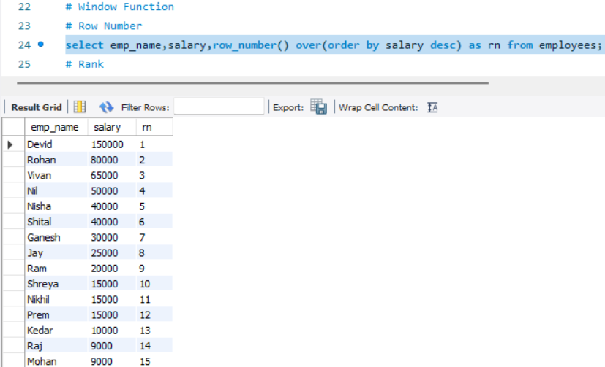
# Rank
- select emp_name,salary, rank() over(order by salary desc) as rnk from employees;
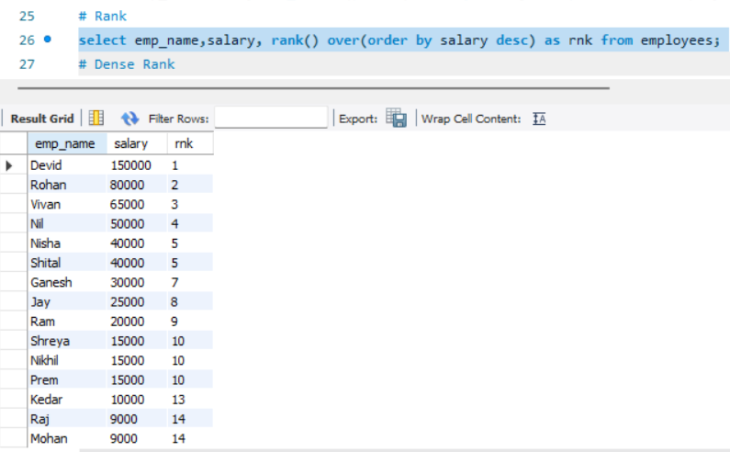

# Dense Rank
- select emp_name,salary,dense_rank() over(order by salary desc) as drnk from employees;
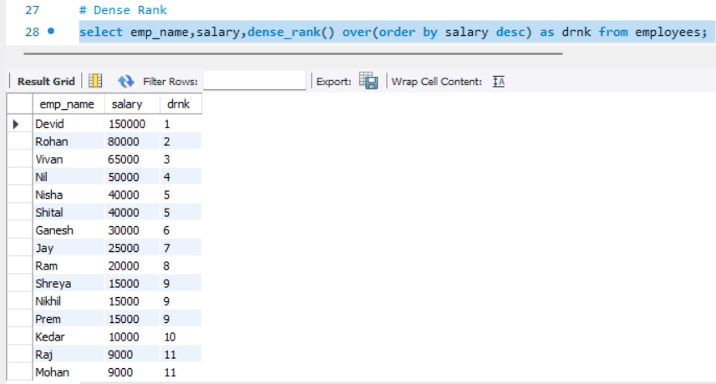

# Sum() Over()
- select salary, sum(salary) over(order by emp_id) as Running_Total from employees;
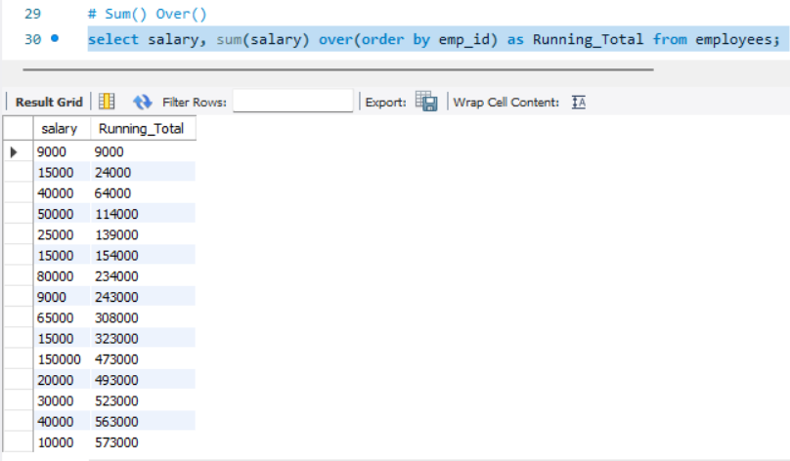

# Avg() Over()
- select emp_name,salary,avg(salary) over() as avg_salary from employees;
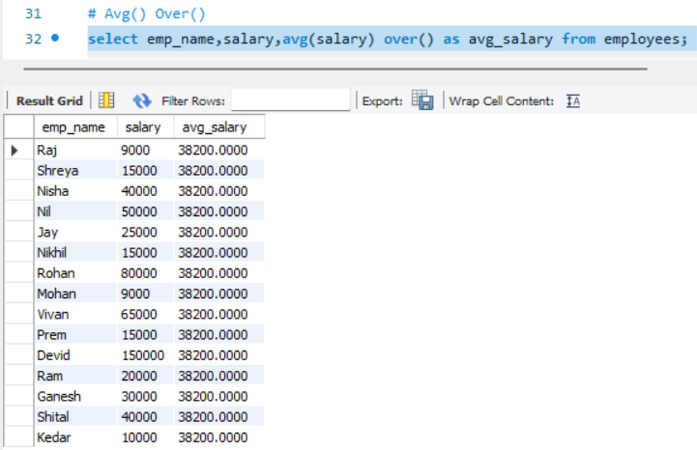
# Partition Bt with Avg()
- select emp_name,dept_id, salary, avg(salary) over (partition by dept_id) as did_avg from employees;
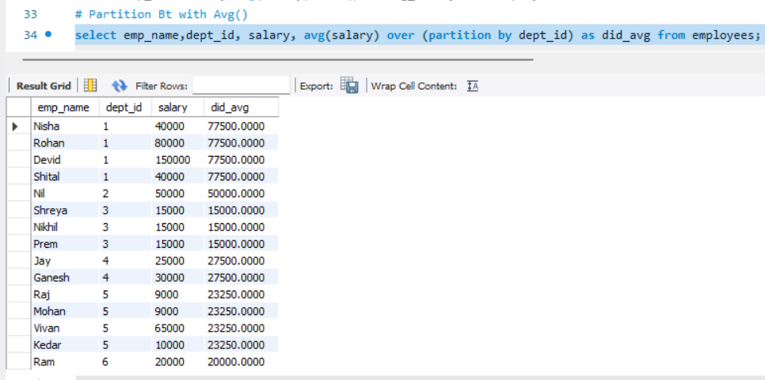

# Lag()
- select emp_name,salary, lag(salary) over (order by salary) as previous_salary from employees;
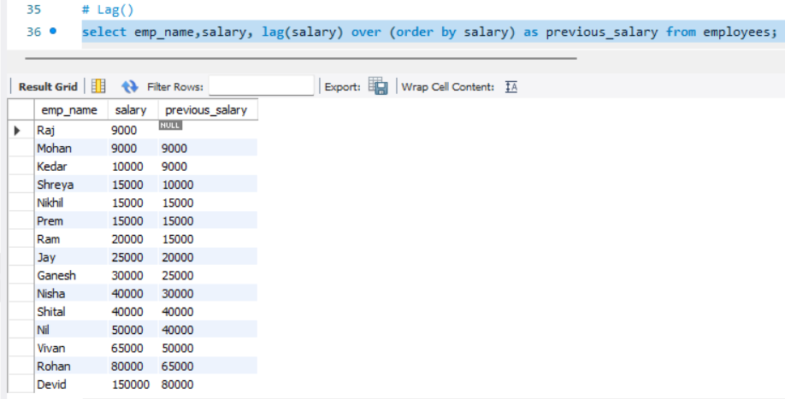

# Lead()
- select salary,lead(salary) over (order by salary) as next_salary from employees;
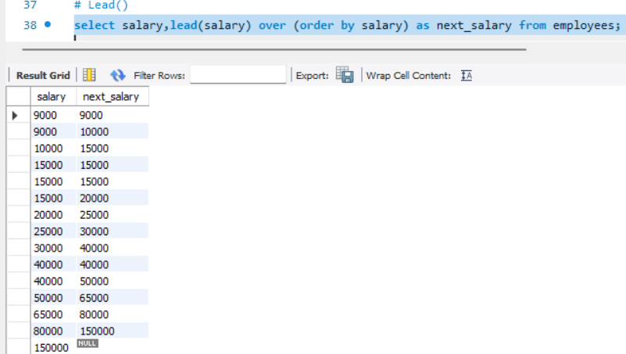

# First_value

- select emp_name, salary, first_value(salary) over(order by salary desc) as highest_salary from employees;
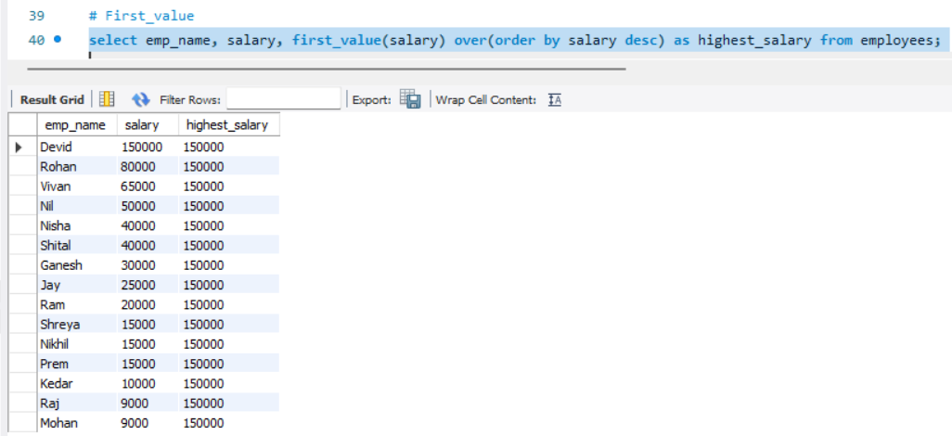
# Last values
- select emp_name, salary, last_value(salary) over (order by salary rows between unbounded preceding and unbounded following) as last_values from employees;
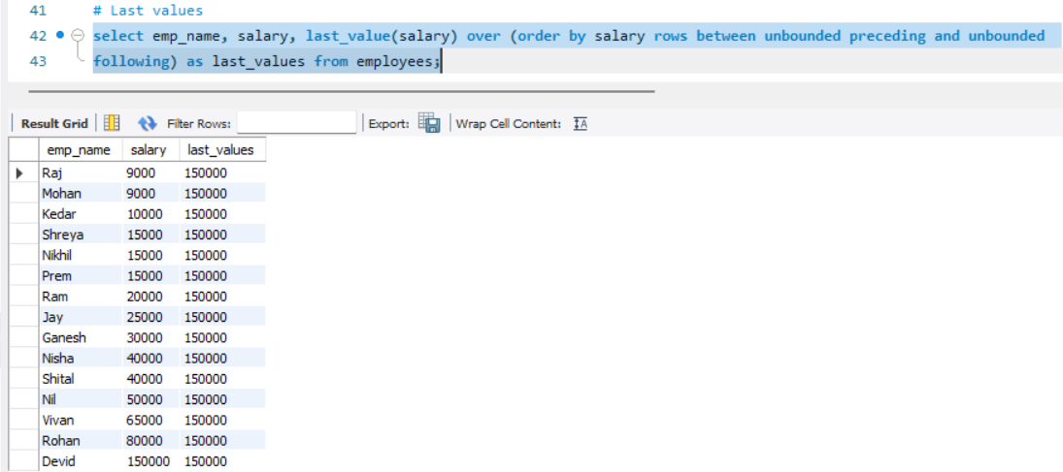

# Case When
- select emp_name ,case when salary > 100000 then "High Salary"
when salary > 50000 then "Medium Salary"
else "Low Salary"end as salary_catogories from employees;
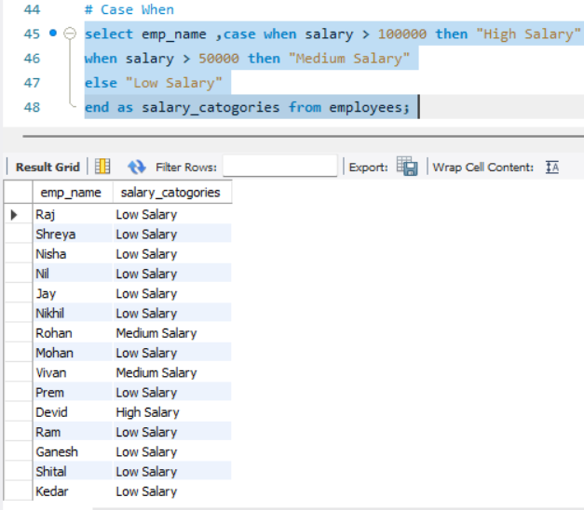
# Case With Order By
- select * from employees order by case when emp_id = 101 then 1
when emp_id = 102 then 2
else 3 end;
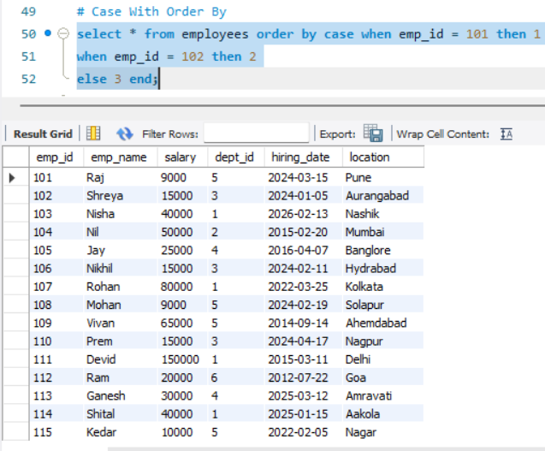
- select year(hiring_date) as year, emp_name ,salary, case when salary >= 100000 then 'Eligible'
else 'Not Eligible' end as bouns_status from employees order by(hiring_date);
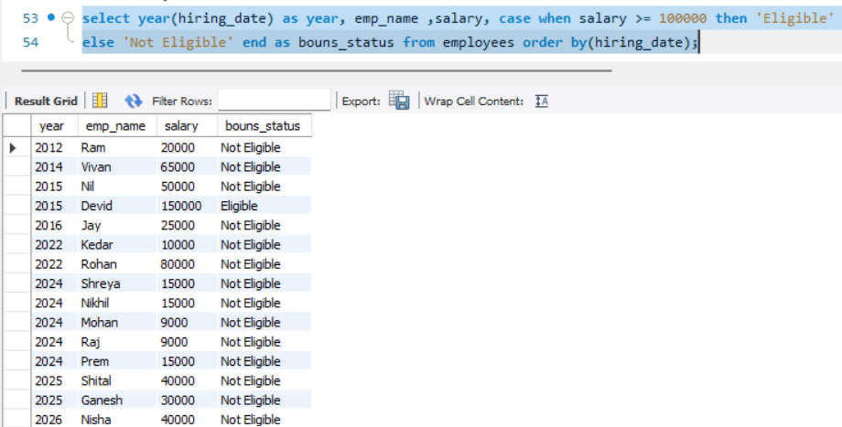
# View
# Create View
- create view emp_view as select emp_id, emp_name, salary from employees;
select * from emp_view;
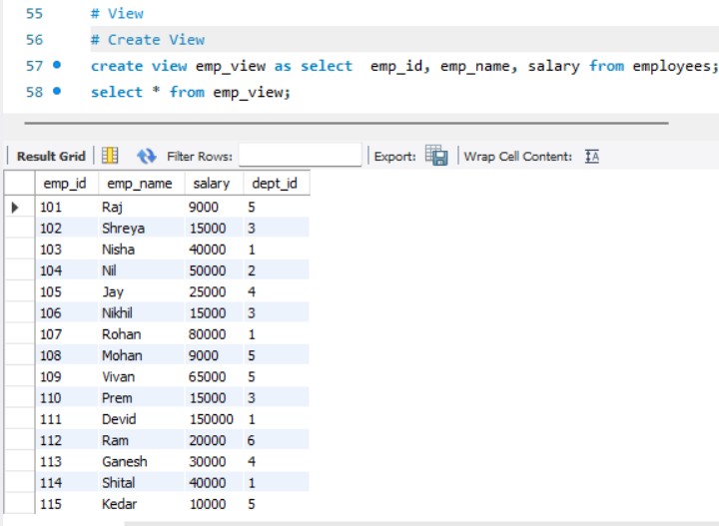
# Replace View
- create or replace view emp_view as select emp_id,emp_name,salary,dept_id from employees;
select * from emp_view;
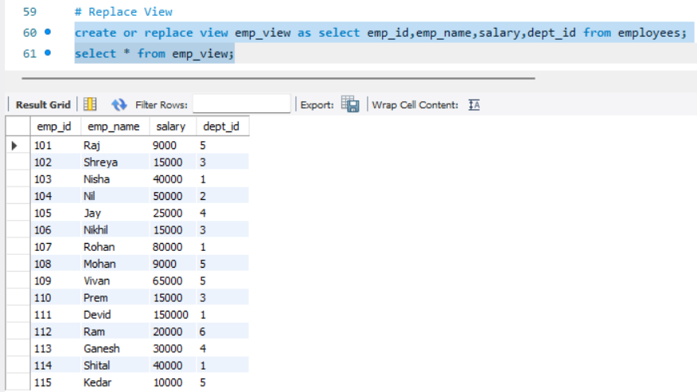
# Join with View
- create view employee_details1 as select e.emp_name,d.dept_name from employees e inner join departement d on e.dept_id = d.dept_id;
select * from employee_details1;
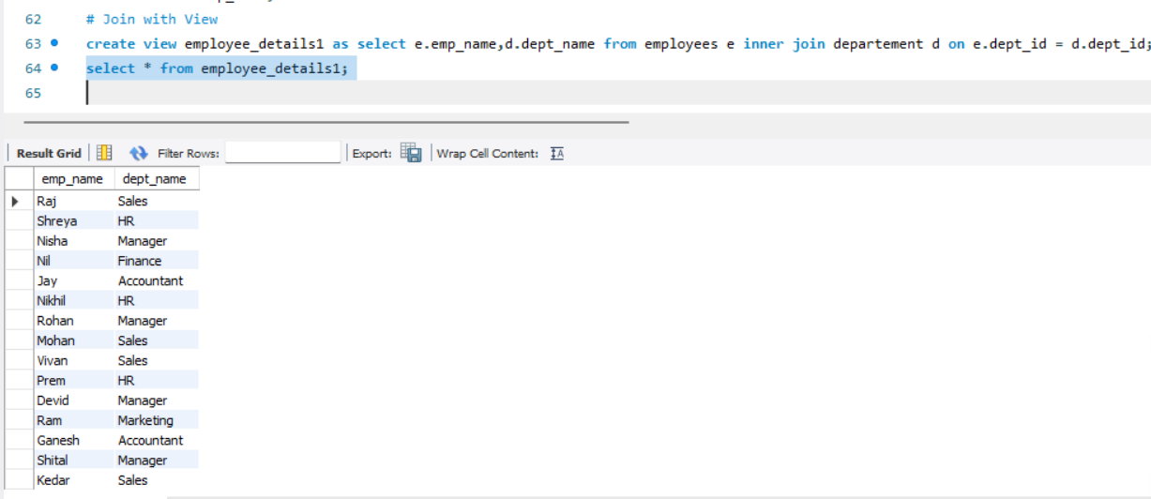

# Trigger
- create table logs(
dept_id int auto_increment primary key, message varchar(100));

DELIMITER $$
CREATE TRIGGER dept_after_insert
AFTER INSERT
ON departement
FOR EACH ROW
BEGIN
INSERT INTO logs(message)
VALUES('New Departement Added');
END $$
DELIMITER ;
INSERT INTO departement
VALUES(7,"Visiting");
select * from logs;
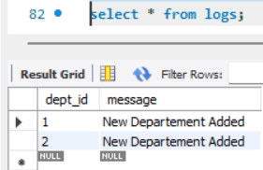

show triggers;
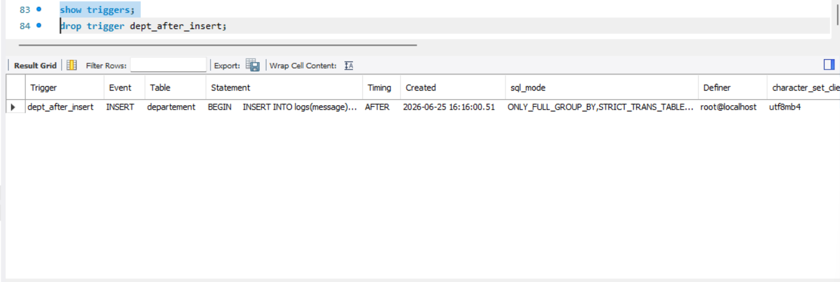
drop trigger dept_after_insert;

